Miller Kids University Newsletter 2027

A shape is the form of an object. It has an outline or outer boundary. Some two-dimensional shapes like circles and ovals are formed by curves. Polygons are shapes connected by line segments such as triangles, squares, and rectangles. Some shapes have names for how many sides they have like pentagons have 5 sides. Hexagons have 6 sides. Octagons have 8 sides.

Math and art are connected in a variety of ways. Art often uses shapes, patterns, lines, angles, perspective, symmetry, and proportions. Perspective is the technique used to represent three-dimensional objects on a two-dimensional surface to create an illusion of space and depth on a flat surface. Symmetry is a balance between various parts of an object. Proportion is how one part of an object relates to the whole object in size like the size of an arm in relation to the rest of the body. Some artists create artwork of shapes. Piet Mondrian (1872-1944) was a Dutch painter of modern abstract art. He is most famous for creating abstract paintings of colored squares, rectangles, and thick black lines.

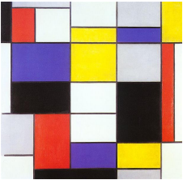

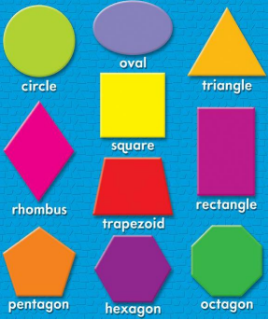

Make a drawing using shapes.

