Magic square

In a magic square, the numbers in every row, column, and diagonal add up to the same amount.

In this magic square with 4 rows and 4 columns, you can add a row, column, a diagonal, the 4 corner numbers, or the 4 center numbers to get the same sum. The 4 numbers add up to 34.

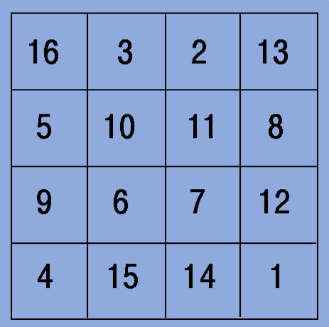

In this magic square with 5 rows and 5 columns, you can add a row, column, or a diagonal. The 5 numbers add up to 65.

