Miller Kids University

2028 Newsletter

Museum Writing Project: Visit a museum or a museum website and write about something that you see. It could be about science, history, geography, culture, or art.

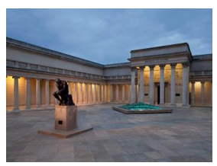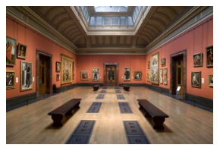

Creative Lunch Bag: Decorate a brown paper lunch bag with crayons or markers. Make a lunch such as a sandwich and a piece of fruit like an apple or banana to put in the bag and give it to a friend or family member.

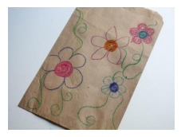

Cooking is a creative process. After you have learned the basic skills of cooking and practiced making recipes and preparing food, you can develop new recipes and meal ideas. Sometimes instead of following a recipe, find ways to change it to create something different. Experiment, mix and match, and design meals. Experiment with flavors and textures of food. Use creative thinking and problem solving to decide what to cook based on the food and cooking tools you have available, who you are cooking for, and what you want or need to make. Cooks have many choices of ingredients, cooking methods, and cultures to explore what it is possible to do with food. Use creative cooking skills to make food that tastes and looks good. They are endless ways to prepare and display all types of food. For cooking ideas, check out cookbooks from the library, watch cooking videos, and find recipes online.